Quality of Care Report 2024

Rascals is registered with Care Inspectorate Wales (CIW) to provide out-of-school care for up to 40 children, ages four to eleven. It is committed to continuously improving the quality of the out-of-school childcare it offers to children and their parents.

Rascals after school club is a sole trader. Stephanie Peppin, the club manager, is the registered person responsible for the operational running of the club and the person in charge of day-to-day activities. The service is open from 15.30 to 17:45 on Mondays and from 15:30 to 18.00 on Tuesdays through Fridays during school terms.

Our success as a childcare provider can be measured in multiple ways. Having been in operation for 28 years, we have consistently received positive feedback from satisfied parents, some of whom joined our waiting lists years in advance.

In addition to our longstanding presence in the community, we conduct annual surveys to gauge our children's and their parents' satisfaction levels. We value their opinions greatly and use their feedback to identify areas for improvement, implementing their suggestions whenever feasible. Our dedication to constantly improving our service and ensuring both children and guardians are happy has made us known as a trusted and reliable childcare provider in the area.

Leadership and Management

Stephanie Peppin reviews the CIW standards each year to ensure that the club continues to comply. She also prepares the club’s Quality of Care report, manages the club's finances and collects parents' payments.

Three staff members (the Manager and two playworkers) are qualified to level 3 childcare, with two further members holding a level 2 childcare qualification and another holding an NNEB. The Manager ensures that all staff receive safeguarding, first aid, and food hygiene training. New staff members receive induction training, and an annual appraisal takes place for all staff in the autumn term. The staff work well together and make a good team.

The staff actively promote equality of opportunity and anti-discriminatory practices for all children. There is an equal opportunities policy in line with the Equality Act 2010, which is understood by all staff and communicated to parents. There is also a complaints procedure in place in the club, of which all parents and children have been made aware. In addition, the club has an extensive web page that provides parents with all the information regarding the club’s management. This page is very well used by parents.

Care and Development

The Club Manager is assisted by 10 assistant play workers over the course of a week. We work to ensure that staffing levels are a ratio of 1 to 8 for children aged 4 to 11. Staff collect children from their classes at the end of the school day and bring them to the club.

All parents sign a contract with the club before or during a child’s first session. Parents also fill in an information sheet showing staff each child's needs, e.g., medical and dietary. The club keeps records about the children, including their personal details, needs and emergency contacts, in a locked cabinet.

No child is allowed into the club if they're experiencing symptoms of being unwell. Parents are informed of any illnesses or accidents that occur during club hours. The club carries a First Aid box, and there is always a member of staff on duty who is first aid trained. The club has a clear policy on the administration of medication. Parents can consent to prescription medication being given to a child, providing they are well enough overall to attend the club and their condition is not contagious. The club keeps records of any medicines administered.

The club also has a clear Behaviour Management Policy, including approaches to dealing with bullying. All staff adopt a positive approach and encourage the children to behave well through good role-modelling, praise, respect, and clear behaviour expectations. Staff observe the children at play to ensure they are interacting positively.

We are delighted to report that Rascals After School Club is performing exceptionally well, as per the feedback from the parents and carers of the children who use our services. Based on the questionnaire responses, parents reported that their child or children enjoy being at Rascals either "most of the time" (33%) or "all of the time” (67%). Parents also responded that their child or children find the club's activities interesting "most of the time" (42%) or "all the time" (58%).

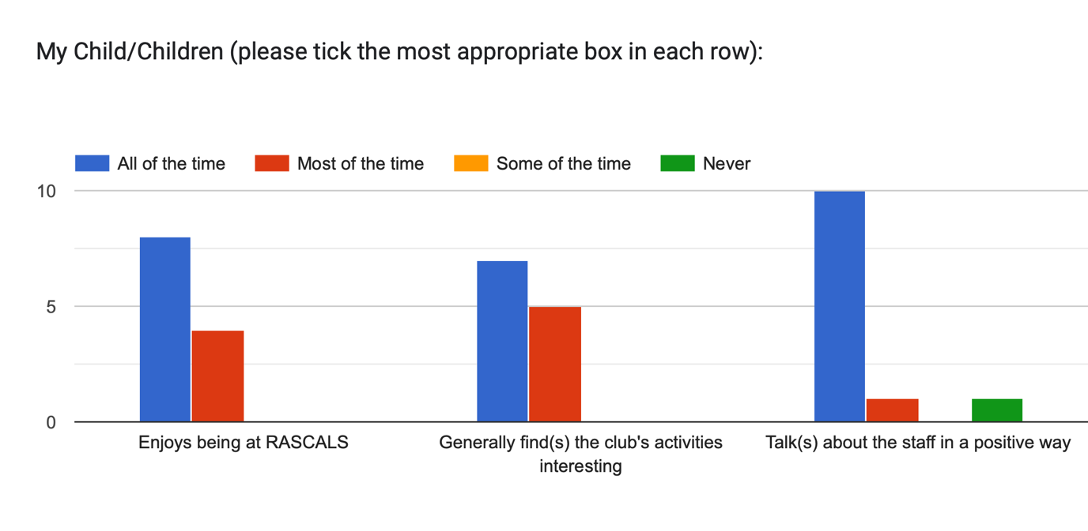

Moreover, the positive feedback regarding our staff is genuinely heart-warming, with 92% of parents reporting that their child or children talk positively about the staff either "most of the time" or "all of the time". One parent stated, "Great club, good value for money, and [Child’s Name] loves his crafting sessions!” while another parent said, " A fantastic club with lovely staff."

We also take pride in our communication with parents and carers, as demonstrated by the high percentage of positive responses received when asking about the approachability of staff members when seeking further information about their child's day and the quality of club policies and procedures (given at registration). For both questions, 92% of respondents rated these areas of communication and information as "excellent", with the remaining 8% rating it as “good”.

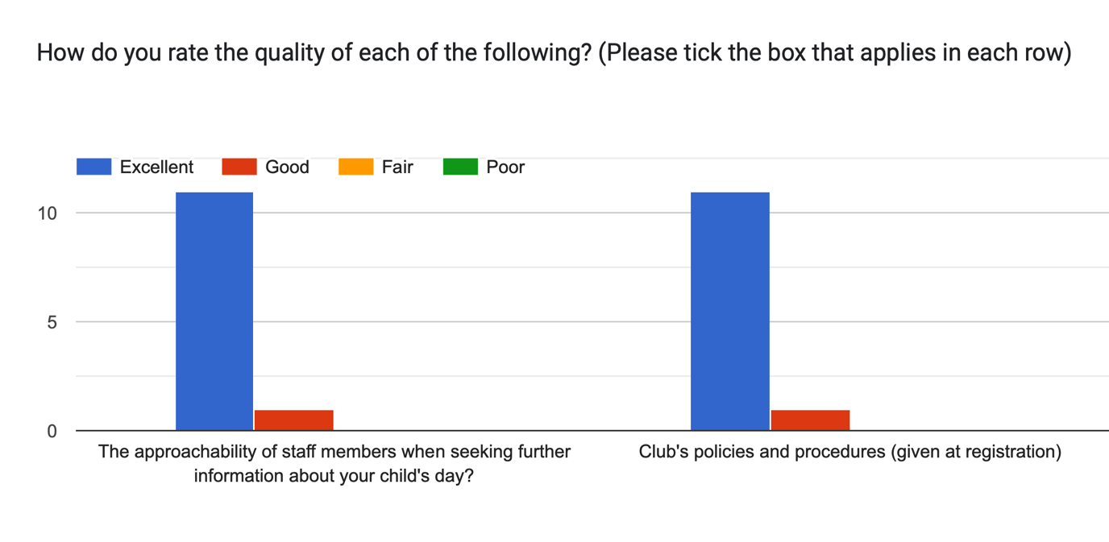

Our commitment to meeting each child's individual needs is demonstrated by the fact that 100% of parents either agreed or strongly agreed that Rascals After School Club meets the individual needs of their child or children. All the parents agreed or strongly agreed that the club's hours worked for them and provided value for money.
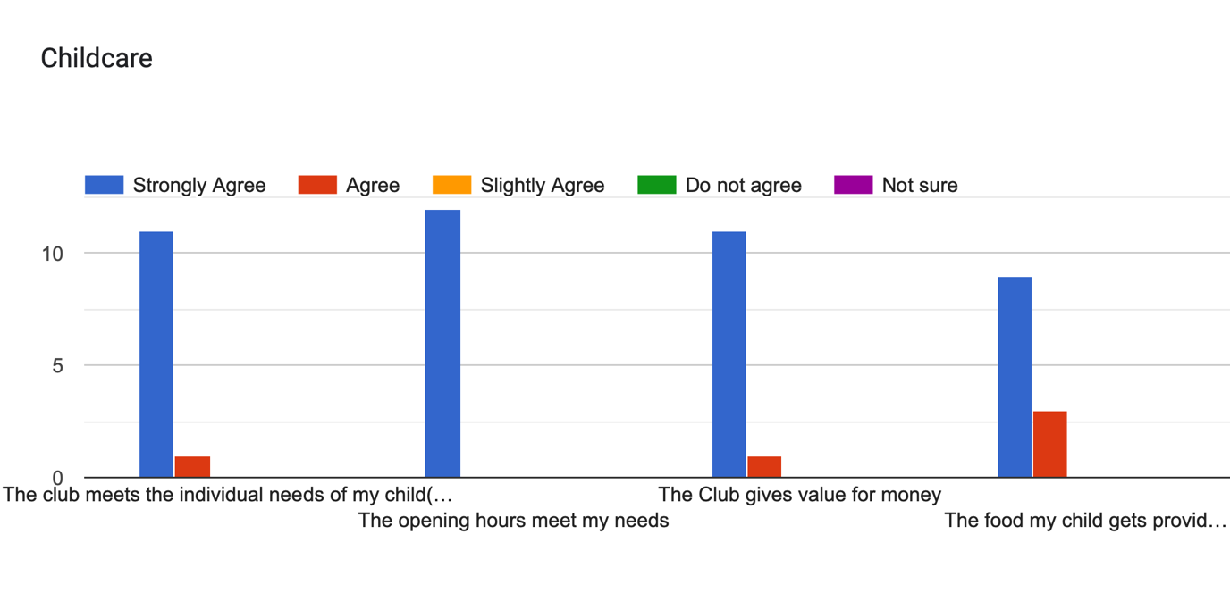

Wellbeing
We are also pleased to report that 100% of parents were satisfied or very satisfied with Rascals After School Club's service.

Parents noted that the staff at Rascals provided fantastic service and outstanding care for their children. One parent stated, “Very well managed club. Supportive staff. Breakfast/Preschool care would be very helpful”. Another parent commented, "Very pleased with the club. All 3 of our children have enjoyed [attending].” Children were quick to echo this opinion in our Children’s Questionnaire by saying, “All the Rascals ladies are really nice”, “[It’s] better than sitting at home because there is more variety”, “It's really fun. People are kind to me.” etc.
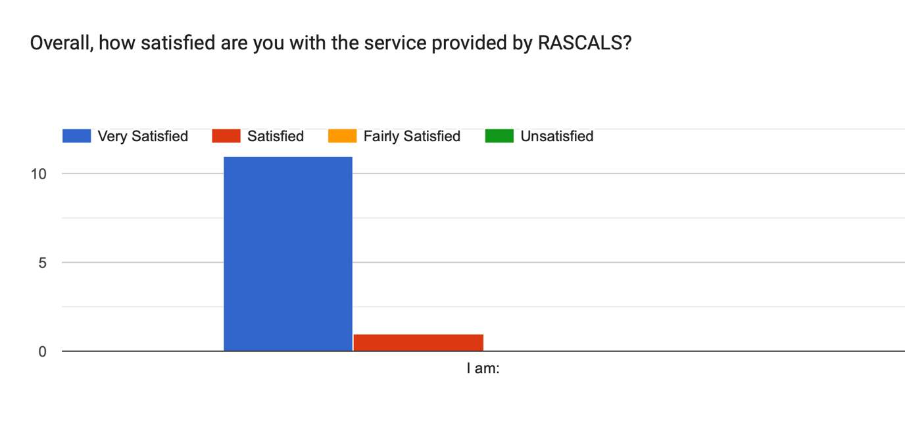
The questionnaire responses indicate that the needs of those who use the service are being met and that the club does an excellent job caring for and assisting children. One parent said, " The ability for the children to attend the after school clubs and then be collected by your staff is helpful”.

These numbers show that Rascals After School Club is an excellent service that gives children a safe, fun, and stimulating place to go after school. We are pleased with our accomplishments and look forward to continuing to serve our parents, carers, and children with distinction.

With a range of activities available every day, the children can choose to play independently with activities (e.g., Lego, game consoles, arts and crafts, etc.) or join staff on more planned and supervised tasks that alternate throughout the year, e.g., seasonal crafts, religious celebrations, bingo etc.)

Children are encouraged to be independent in storing and retrieving their bags and coats, choosing activities, and tidying up after themselves.

Children are consulted regularly about what they want to do and what activities and resources should be available. When asked if they enjoyed being at Rascals, all of the children responded positively. Most children enjoy their time at Rascals because they can spend time with friends from their own and other years. In addition, many children appreciate the variety of entertaining and engaging activities. Some children mentioned that they enjoy arts and crafts, while others noted that they enjoy playing video games or using the computer.

This year, a wide range of new resources have been purchased in response to children's requests, including more board games, Xbox/Nintendo Switch games, dinosaur-themed toys, and arts and crafts materials.

Rascals provide a warm and enjoyable atmosphere for the children who attend.
100% of children responded “Yes” when asked, “Do you feel safe and comfortable at Rascals?” and indicated that they felt comfortable asking staff for assistance. We also asked the children if there was anything we could do to improve safety or comfort, to which all children responded, “Nothing”, “No, it's perfect”, and other quotes like “I'm happy with everything”. These responses indicate that Rascals offers a welcoming and inclusive environment where children can thrive.

Environment
Rascals is based in the 2nd Rhiwbina Scout Hall. The club has access to a newly fitted and well-equipped kitchen, toilets, a large main hall (including a play area, reading area, and toy kitchen) and an extensive field.

A wide range of toys and play materials are available to the children, which are accessible and appropriate for their age. In addition, there are sufficient chairs and tables available.

The Manager visually inspects the premises and equipment to ensure safety before commencing activities. Playworkers are also encouraged to report faulty or broken equipment and to ensure they are removed from the area safely. Any problems are reported to the Manager.

Negotiations with the property owners occur regularly, and several improvements have been made to the kitchen. In addition, the club has flower tubs and a bird box.

Fire drills are held termly to ensure all children and staff know the evacuation procedure. Smoke detectors are fitted throughout the building, and fire blankets and extinguishers are located around it. FireRite annually checks these.

The lane leading up to the hall has also recently been resurfaced and is usually swept twice a year.

Evaluation

In conclusion, we acknowledge that there is always an opportunity to improve as a childcare provider. This may include enhancing our digital communication and presence or regularly revisiting our resources and selection of toys and activities. By continuously seeking to improve and adapt, we are committed to providing the best possible experience for the children in our care and their families.

